**Implementation**

All attachment videos will be named equivalent to the test

**Stage 1 – Basic Layout**

Within this first stage when developing my app, I had done a large recreation of my UI. This is due to when I had gone for user feedback within my focus climbing group the general output was that the view was not very nice. Many agreed that the strong red vs white contrast wasn’t very visually appealing. Yet, they had no bad comments about where everything is positioned and how it is laid out. The only issue was the colour. As well as this when receiving my feedback and reviewing my design and analysis I had realised I hadn’t looked up and researched any good layouts. As, my main issue, with all the other similar projects that I had researched, was that the layout wasn’t very appealing. Therefore, from this I did a large recreation of the colour scheme.

Within my focus group, one person had recommended the colours for the app:

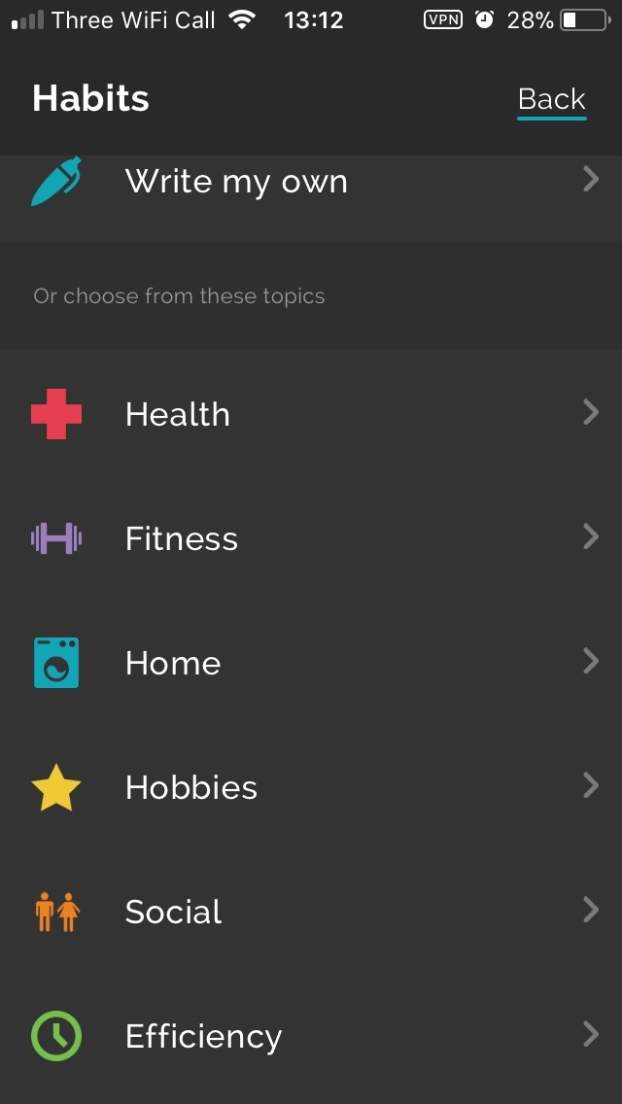

**Productive – Habit Tracker**

Once seeing this I saw that the colour scheme was very nice, minimal and sleek. As well as this they use a lot of dark colours, then will have multiple bright colours to create a strong contrast on the background.

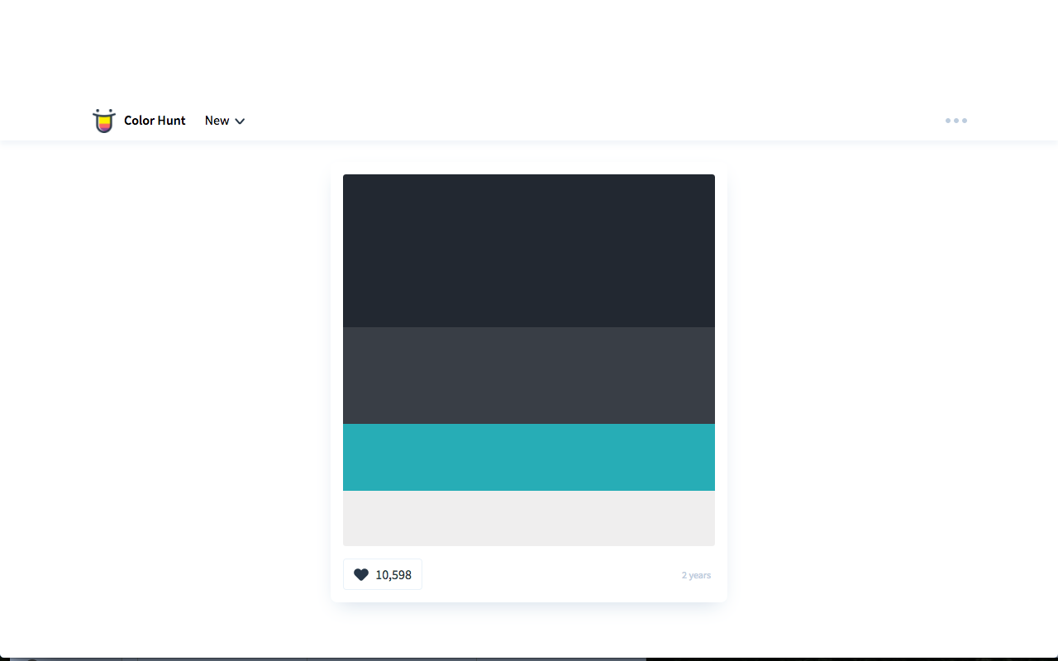

Therefore, from here I realised that using dark colours look much nicer and much more slick. So I went onto the website: ColorHunt. Here I found this colour scheme. From this I decided that the first colour will be for the background. Second for lines/separations and details. Third, for buttons. And last for text.

The following screenshots shows my final UI.

**Home**

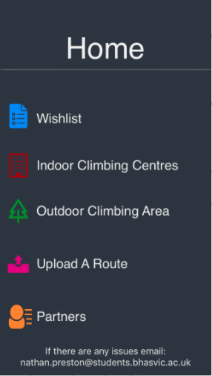Here you can see that I have used much calmer colours for the text and background, and used more colours in total. Firstly, I have used calmer colours as it is much more straining on the eyes. Secondly, using a light grey for the text, dark grey for the separator and a navy background presents a stronger differentiation between it all which is still very aesthetically pleasing.

Next I have used a new colour for each part as it shows a very clear differentiation for each section of my app. Doing this can make a mental link with the colour to the section. As well as this I have made an icon for each section, as I felt it was much more aesthetically pleasing and once again created an obvious differentiation between each section.

However, I have still used the same structure as I had planned.

**Wishlist**

Here for the all the back buttons and the home buttons I have used a light blue to make a very clear option to go back. Yet it isn’t an eye saw. Therefore, it makes the new layout much easier to navigate and much nicer to look at.

Similarly, to my old layout I have made a new icon for going back a page if the page before isn’t the home page, I have used a basic backwards arrow. I used this instead of my original idea as its much nicer too look at, plus as my new UI is very heavy upon icons I thought it would be satisfying with for the user if the pattern was followed.

**Indoor Outdoor**



**Climbing Centres Routes**

**Partners**



**Upload Details Upload a Route**



**Test 1 – Video 1**

|  |  |  |  |  |
| --- | --- | --- | --- | --- |
| **Test No.** | **Description** | **Test Data** | **Expected Result** | **Actual Result** |
| 1a | Checking whether the app will open without it crashing/without error | -Icon Click  -Valid | App Opens without error | Runs without error |
| 1b | Checking button for Indoor Gym works without error | -Button Click  -Valid | Indoor Gym Section opens | Runs without error |
| 1c | Checking button for Outdoor Area works without error | -Button Click  -Valid | Outdoor Area Section opens | Runs without error |
| 1d | Checking button for Wishlist works without error | -Button Click  -Valid | Wishlist Section opens | Runs without error |
| 1e | Checking button for Upload A Route works without error | -Button Click  -Valid | Upload A Route Section opens | Runs without error |
| 1f | Checking button for Partners works without error | -Button Click  -Valid | Partners Section opens | Runs without error |
| 1g | Checking button for Upload Details works without error | -Button Click  -Valid | Upload Details  Section opens | Runs without error |
| 1h | Checking button for home works without error | -Button Click  -Valid | Home opens | Runs without error |
| 1i | Scrolling up and down the pages | -Scroll  -Valid | Page scrolls | Runs without error |

**User Feedback**

I asked a focus group what they liked and disliked about my UI. The general feedback was that it was a very nice layout, but the general dislike was that the area to press an icon was too small. So to fix this I will make the area to be clicked larger, via creating a transparent space that you’ll be able to click.

**Stage Two – Interactive Map**

When implementing my map, I had encountered two very large errors, however they were all due to similar reasons. The main cause was the way I was going to have Stage 3 and Stage 2 work together.

As when I began this stage I knew that I would have to start a little bit of stage 3, as I need to go through a button to a climbing centre to get to the interactive map. Therefore, at the beginning of developing this stage I realised it would be much more efficient with time and storage to create a table and add all the centres there, rather than creating a view controller for each climbing centre.

This was as, this method meant that I only had to create one view controller, then depending on what place was chosen the necessary information would be filled in from variables and arrays. As well as this, within stage three I want to implement a search bar, and doing that in a table would be far easier and work much smoother, giving a smaller area for error.

**Test 1**

|  |  |  |  |  |
| --- | --- | --- | --- | --- |
| **Test No.** | **Description** | **Test Data** | **Expected Result** | **Actual Result** |
| 2a | Scrolling Around | -Map Scroll  -Valid | Scrolls without error | Crashed,  FAIL |
| 2b | Zooming In/Out | -Map Zoom  -Valid | Scrolls without error | Crashed,  FAIL |
| 2c | Map starts at the climbing centre | -Boulder Brighton  -Valid | Placement is correct | Crashed,  FAIL |
| 2d | Map starts at a different climbing centre | -Withdean  -Valid | Placement is correct | Crashed,  FAIL |

**Error 1**

../../../../Desktop/Screen%20Shot%202017-10-01%20at%2016.01.

This was my first large error that I had encountered. This error caused my whole program to crash, this was because where I had set the values for my marker, and where the map would be looking, I had force unwrapped my map. This caused the app to crash as it didn’t have a default value, so when it failed to get my data it crashed. To fix this I had put my code from:

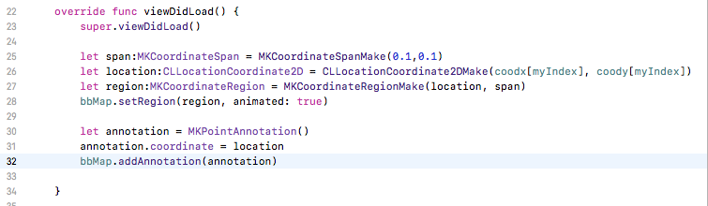

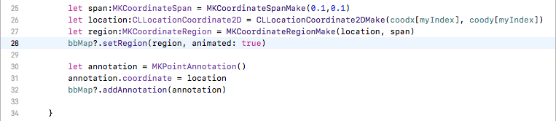To:

Doing this gave the map these values as the default values and were no longer being force unwrapped.

**Test 2**

|  |  |  |  |  |
| --- | --- | --- | --- | --- |
| **Test No.** | **Description** | **Test Data** | **Expected Result** | **Actual Result** |
| 2a | Scrolling Around | -Map Scroll  -Valid | Scrolls without error | Scrolls without error |
| 2b | Zooming In/Out | -Map Zoom  -Valid | Scrolls without error | Zooms without error |
| 2c | Map starts at the climbing centre | -Boulder Brighton  -Valid | Placement is correct | Marker at Boulder Brighton |
| 2d | Map starts at a different climbing centre | -Withdean  -Valid | Placement is correct | Marker at Boulder Brighton,  FAIL |

**Error 2**

This error was also connected to the first error. It was because I had put all the necessary code within the view controller for the page with the map, this includes the code for the table to operate. This was causing my variable which was the click input to always be 0, which meant that it only ever presented the map details for Boulder Brighton. Once I had realised this I put the following code into a separate file, and made the view controller with the table linked to this code. As well as fixing this error doing this meant I no longer needed the ‘?’ in the **Error 1**.

(Please ignore error messages, as it was a recreation after the fix).

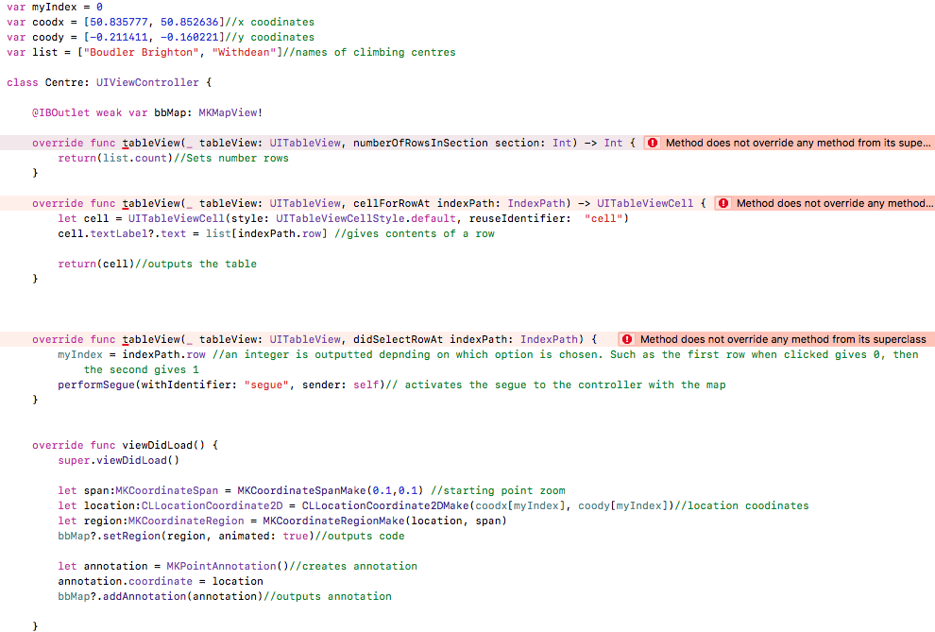

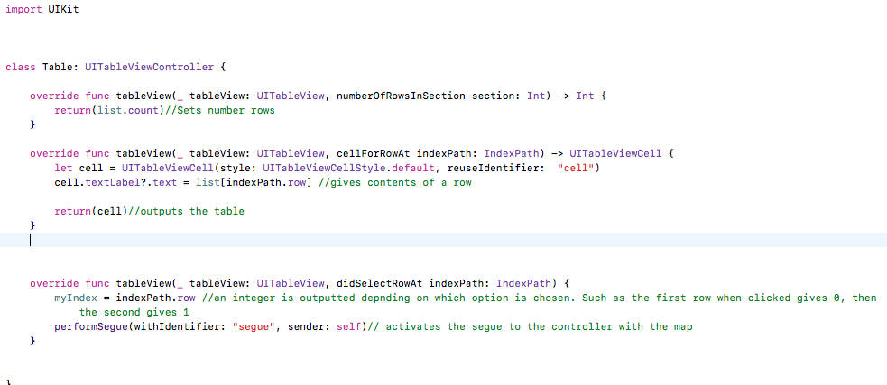**Final Code** (table file)

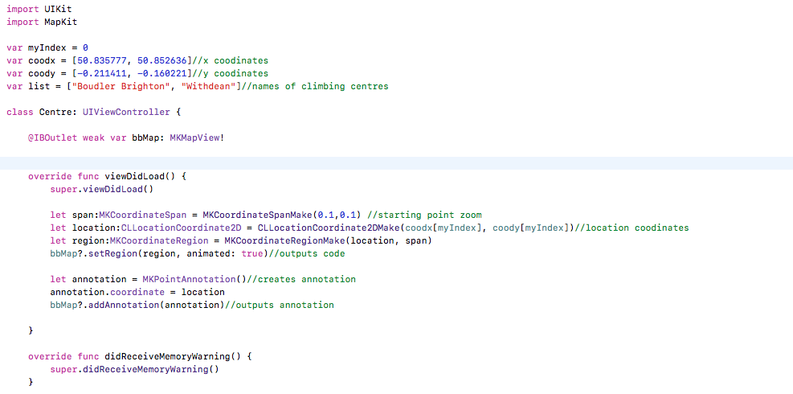**Final Code** (map file)

**Test 3 – Video 2**

|  |  |  |  |  |
| --- | --- | --- | --- | --- |
| **Test No.** | **Description** | **Test Data** | **Expected Result** | **Actual Result** |
| 2a | Scrolling Around | -Map Scroll  -Valid | Scrolls without error | Scrolls without error |
| 2b | Zooming In/Out | -Map Zoom  -Valid | Scrolls without error | Zooms without error |
| 2c | Map starts at the climbing centre | -Boulder Brighton  -Valid | Placement is correct | Marker at Boulder Brighton |
| 2d | Map starts at a different climbing centre | -Withdean  -Valid | Placement is correct | Marker at Withdean |

Before starting Stage 3, decided that took increase usability and ease of use that I would include the user’s location within the map, just to give a fast and simple idea of how far the desired climbing centre is from the user. For this to happen I had to add some parts to my app, such as creating a request to be able to have the user’s location. Therefore, the following is my final code for this section and everything else which was added.

(Code added: 24-26)

**Test 4 – Video 3**

|  |  |  |  |  |
| --- | --- | --- | --- | --- |
| 2e | Map presents user location | -user location  -Valid | Placement is correct | Placement is correct |

**Stage 3 - Inputting Climbing Areas/Gyms Nearby**

Before I added any code I had realised that I would have to create another two swift files. They are identical versions as what I had done in stage two, yet was for the outdoor centres. All the recreated code was exactly the same, except for I had new arrays for everything that related to an outdoor route.

**Test 1**

|  |  |  |  |  |
| --- | --- | --- | --- | --- |
| **Test No.** | **Description** | **Test Data** | **Expected Result** | **Actual Result** |
| 3a | Searching for a specific place | -‘Boulder Brighton’  -Valid | Presents specific place | Crash - FAIL |
| 3b | Searching for an invalid place | -‘John’  -Valid | No climbing centres shown | Crash - FAIL |

**Error 1**

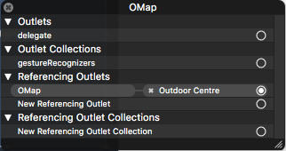When re-creating all of the code for my outdoor area I encountered a very large error that caused my code to crash. It was labelled as: ‘terminating with uncaught exception of type NSException’. It was due to the map which was for my outdoor centres had 3 outlets that I had deleted within the code, however did not remove from the map its self, therefore it followed to a non-existent reference. Once realising this I deleted the invalid outlets allowing the code to run as wanted.

Under ‘Referencing Outlets’ 3 other outlets were made that had no proper reference, as well as ‘OMap’, which is fully functional.

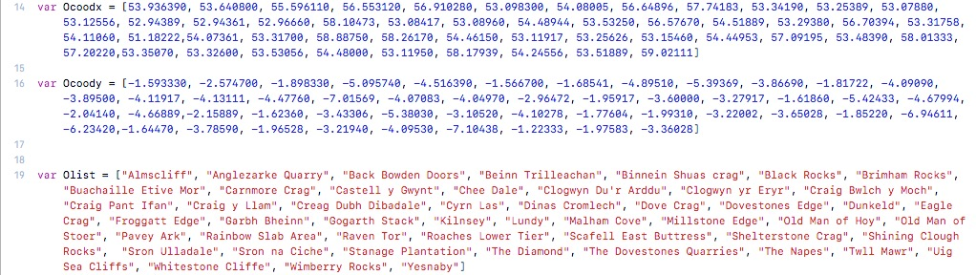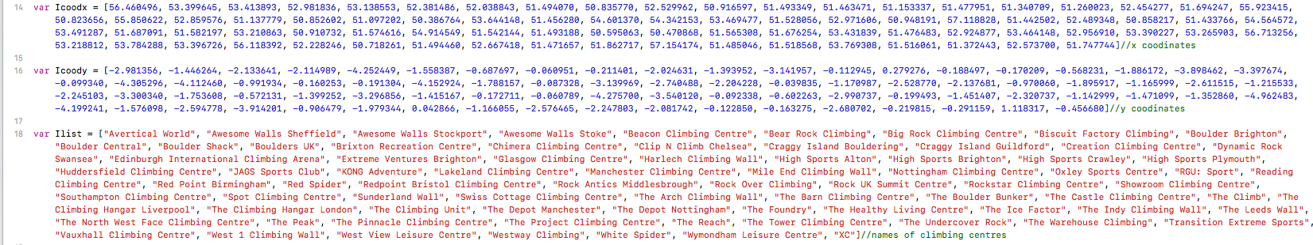As within my Design I mention all the climbing centres that I will add, to achieve this I firstly put all the climbing centres in alphabetical order. Then I would use Google Maps to find each x/y co-ordinates of each location, then added that in order of the climbing centres. I did this as then the index of each location would be identical, making outputting this data to the map very easy.

**Test 2 – Video 4**

|  |  |  |  |  |
| --- | --- | --- | --- | --- |
| **Test No.** | **Description** | **Test Data** | **Expected Result** | **Actual Result** |
| 3a | Searching for a specific place | -‘Boulder Brighton’  -Valid | Presents specific place | Presents specific place |
| 3b | Searching for an invalid place | -‘John’  -Valid | No climbing centres shown | Instead of no climbing centres shown when nothing valid is entered, all are shown. I felt this was a better outcome. |

I added the code to the table file for my search bar, while using <https://shrikar.com/swift-ios-tutorial-uisearchbar-and-uisearchbardelegate/> as a basis to follow to implement my code.

**Error 2**

This code did pass my tests for my Stage 3 tests, however would’ve caused my Stage 2 tests as I had encountered an error. This error was logical, so meant that my code ran fine. However, the error was that when something is searched for the table changes. So if you refer to the final code within Stage 2, I use a variable ‘myIndex’ which changes depending on which cell you chose. This code worked perfect when nothing was searched, however when something is searched the top result will cause ‘myIndex’ to have a value of 0. Yet Ilist[0] would only ever refer to ‘Avertical wall’. Therefore, I added the following to my code for a climbing centre to mean that the correct index was used if the search bar was used.

**Indoor** (IndoorCentre File)

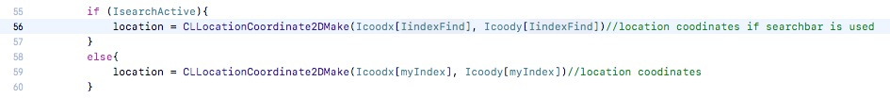

**Outdoor** (OutdoorCentre File)

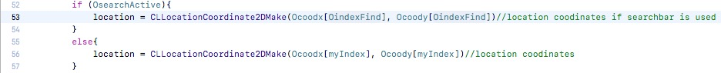

Afterwards I felt that once you had inputted something into the search bar, that I was necessary to be able to remove the keyboard, if one felt it was no longer necessary. The following code was added to the table file.

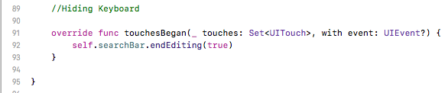(lines 91-93, 66, 71)

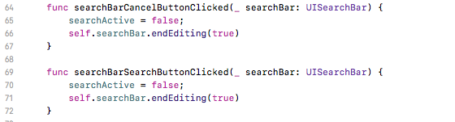

Stage%203/Table%20colour.pngAs well as this added a small piece of code into my table file to make the table a light grey instead of white, to follow the colour scheme of my app.

**Stage 4 – Partners Section**

To create functional tests and make the integration of the data base smoother, I made multiple arrays that acts as the database for each collection of data. Then I created a simple table view, like I have with the previous stages. From there I created a collection of text fields that link into my code as inputs.

**Test 1**

|  |  |  |  |  |
| --- | --- | --- | --- | --- |
| **Test No.** | **Description** | **Test Data** | **Expected Result** | **Actual Result** |
| 4a | Inputting no data to see if the validation has worked | -Invalid | Rejection of data. | Crash when trying to upload  FAIL |
| 4b | Inputting data into First Name, but not into Email or Phone Number. | -‘Nathan’  -Invalid | Rejection of data. | Crash when trying to upload  FAIL |
| 4c | Inputting data into Email, but not into First Name or Phone Number. | -‘np@aol.com’  -Invalid | Rejection of data. | Crash when trying to upload  FAIL |
| 4d | Inputting data into Phone Number, but not into First Name or Email. | -‘12345678901’  -Invalid | Rejection of data. | Crash when trying to upload  FAIL |
| 4e | Inputting data into First Name and Email, but not into Phone Number. | -‘Nathan’, ‘np@aol.com’  -Valid | Acceptance of data. | Crash when trying to upload  FAIL |
| 5f | Inputting data into First Name and Phone Number, but not into Email. | -‘Nathan’, ‘12345678901’  -Valid | Acceptance of data. | Crash when trying to upload  FAIL |
| 4g | Inputting data into First Name and Email and Phone Number. | -‘Nathan’, ‘n@aol.com’, ‘1234567890’  -Valid | Acceptance of data. | Crash when trying to upload  FAIL |
| 4h | Inputting data that has already been used. | -‘Nathan’, ‘np@aol.com’, ‘12345678901’  -Invalid | Rejection of data. | Crash when trying to upload  FAIL |
| 4i | Inputting data into description | -‘Nathan’, ‘np@aol.com’, ‘12345678901’  ‘I like climbing’  -Vali | Rejection of data. | Crash when trying to upload  FAIL |

**Error 1**

When trying to upload any details into my code I would crash and give the following error:

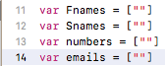The cause to my error was due to my bad declaration of my arrays. I declared them like:

These declarations are incorrect as it only has one piece of data, so when attempting to append to the code it would overflow and crash. Therefore, I made a simple fix and made it into the following:

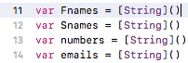

**Test 2 – Video 5**

|  |  |  |  |  |
| --- | --- | --- | --- | --- |
| **Test No.** | **Description** | **Test Data** | **Expected Result** | **Actual Result** |
| 4a | Inputting no data to see if the validation has worked | -Invalid | Rejection of data. | Rejection of data. |
| 4b | Inputting data into First Name, but not into Email or Phone Number. | -‘Nathan’  -Invalid | Rejection of data. | Rejection of data. |
| 4c | Inputting data into Email, but not into First Name or Phone Number. | -‘test1@aol.com’  -Invalid | Rejection of data. | Rejection of data. |
| 4d | Inputting data into Phone Number, but not into First Name or Email. | -‘12345678901’  -Invalid | Rejection of data. | Rejection of data. |
| 4e | Inputting data into First Name and Email, but not into Phone Number. | -‘Nathan’, ‘test2@aol.com’  -Valid | Acceptance of data. | Acceptance of data. |
| 5f | Inputting data into First Name and Phone Number, but not into Email. | -‘Nathan’, ‘12345678901’  -Valid | Acceptance of data. | Acceptance of data. |
| 4g | Inputting data into First Name and Email and Phone Number. | -‘Nathan’, ‘test3@aol.com, ‘987654321’  -Valid | Acceptance of data. | Acceptance of data. |
| 4h | Inputting data that has already been used. | -‘Nathan’, ‘test3@aol.com, ‘987654321’  -Invalid | Rejection of data. | Rejection of data. |
| 4i | Inputting unique data from each section | -‘John’, ‘John@aol.com’, ‘1111111111’  ‘I like climbing’  -valid | Rejection of data. | Inputted correctly |

**Unplanned Code**

As seen in the video I had added some unplanned code. First was to allow the description box to move into the centre of the screen, whilst it was being edited. I felt this was necessary as it’s nice to have all of the inputs on one screen but when the keyboard appears it would cover up all of the description box, not allowing the user to see what they’re typing. So I pushed it up whilst it is being changed then put it back to the original position once the changes have been finished. The second piece of code was to make a placeholder text. As within Xcode Text Fields have a premade function to allow you to add a placeholder, but for a description I needed multiple lines. So I needed to use a Text View. The code I made was just to change the colour of the font, and make the placeholder text disappear once touched. Plus, if it was untouched to make sure the placeholder text isn’t inputted along with the details of the user.

When creating the table, I had to create a new file to make each cell within the table custom, allowing me to change it the way I want. Very little code went into this file, just references to each piece of text.

**User Review**

When a stakeholder used my app to uploads their details, their biggest issue was that the description box is not very well laid out once in use. They felt that the focus should’ve been more on the text box, and recommended to fade the background or to move all of the page upwards also.

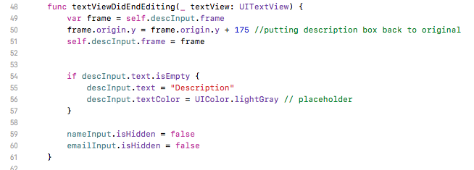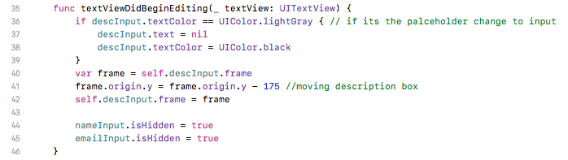

**Stage 5 - Setting Up the Database for Partners Section**

Here I needed to have a server setup as the database for the Partners section must be available for multiple people to connect to. So I followed a tutorial (codewithchris.com/iphone-app-connect-to-mysql-database/) and had Bluehost suggested to use as a host as it is very useable.

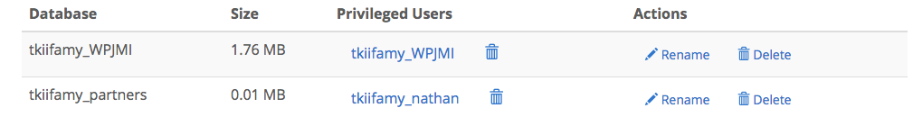So I began by creating a databse within the section MySQL databases. I created one database named: tkiifamy_partners, and connected that to a user named: tkiifamy_nathan. I allowed all privileges for the user and linked them.

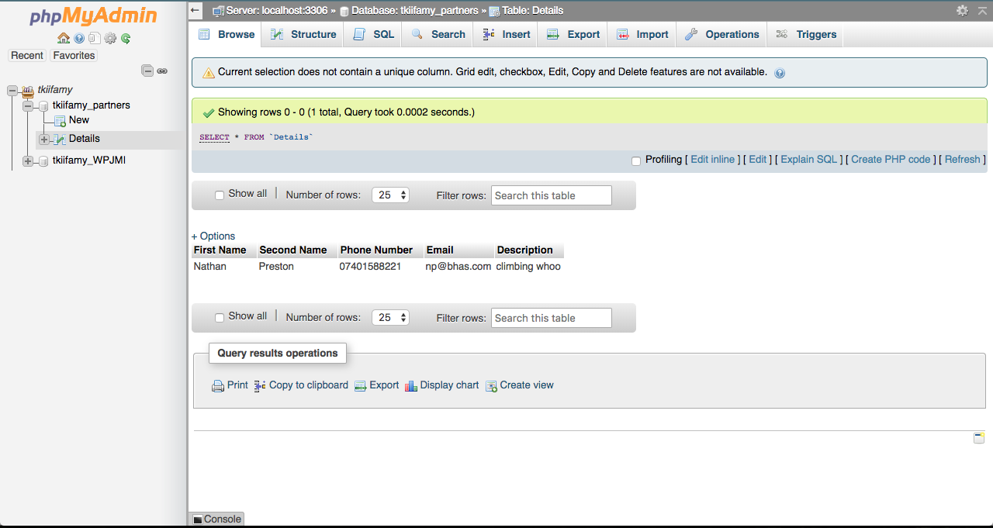From here I used phpMyAdmin to create a table Details within this added my test row of data.

Once all the server part was created I needed to create a php file that would read my table, then output the contents of the table. From that I created two ‘Models’ to handle and store the data passed from the php file. It all gets passed between arrays and repeats error checks, outputting what the error would be.

**Test 1**

|  |  |  |  |  |
| --- | --- | --- | --- | --- |
| **Test No.** | **Description** | **Test Data** | **Expected Result** | **Actual Result** |
| 5a | Setup sections for the partner’s area. So 5 valid inputs. | - ‘Nathan’, ‘Preston’, ‘07401588221, ‘np@bhas.com, ‘climbing whoo’  -Valid | All data inputted without error | All data inputted without error |
| 5b | Outputting data | - ‘Nathan’, ‘Preston’, ‘07401588221, ‘np@bhas.com, ‘climbing whoo’  -Valid | Inputted data will be outputted | Inputted data will be outputted |

From the phpMyAdmin screenshot, you can see that I had added the test data there. Then from the screenshot from my app it shows that how the data had correctly been passed through and added to my app.

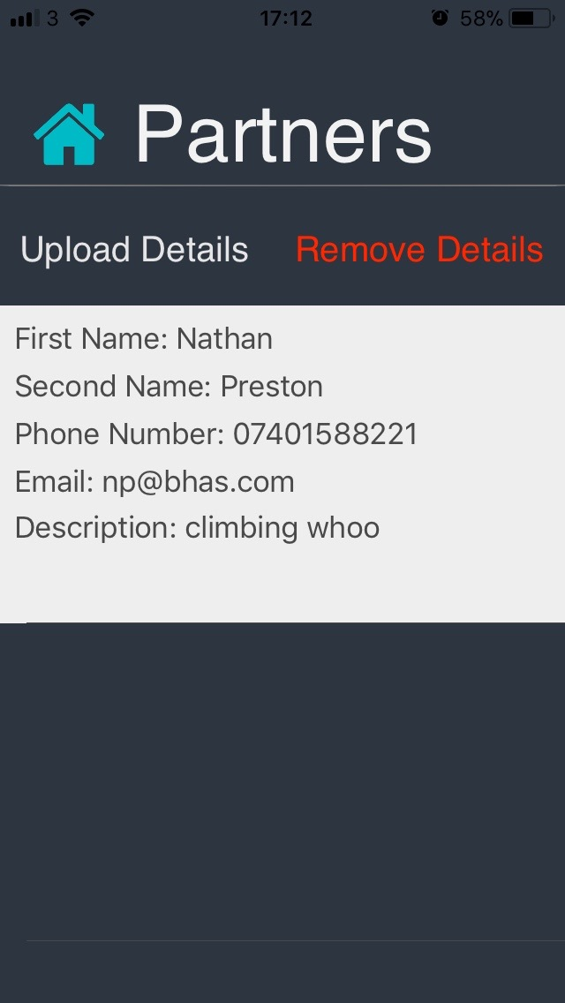

To make this work I had to remove the input to the arrays and change it for an input to a string, which would then be passed to the php file, and then inserted into the database with via SQL.

From:

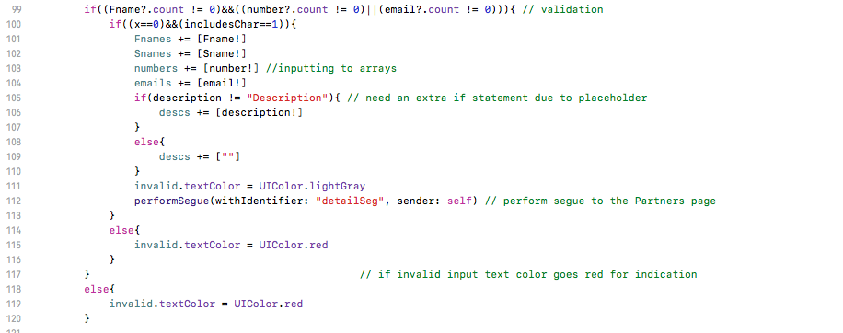

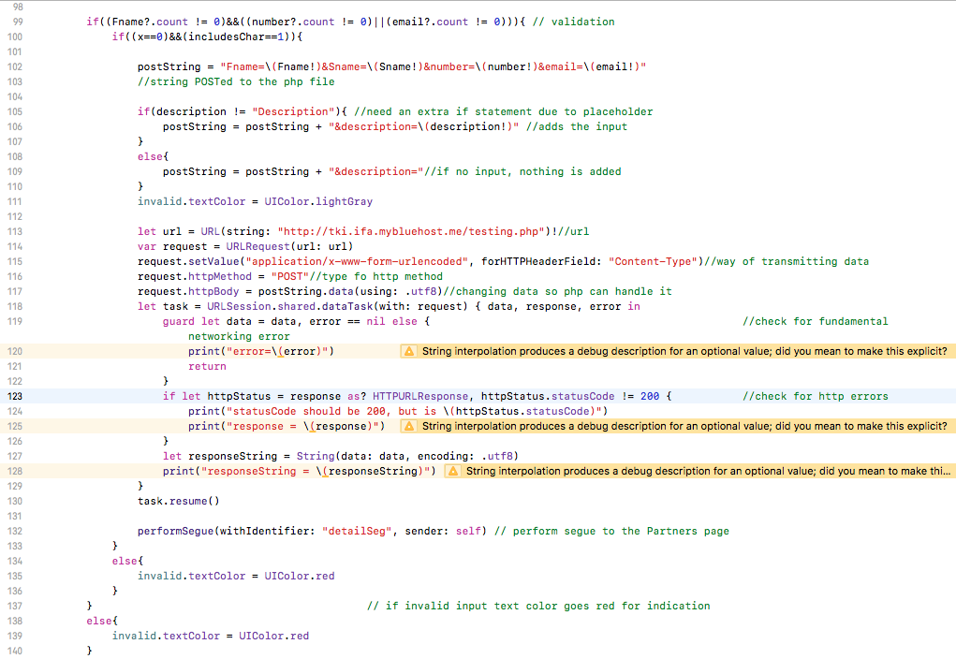To:

**Stage 6 - Uploading Details**

**Errors**

For this section I ran into multiple errors, all of which were due to my misunderstanding of how to POST to a database. I tried to follow multiple tutorials, however most caused lots of errors as they were outdated and as I tried to use multiple tutorials together many syntax errors were caused. The biggest error was due to forgetting a semi colon within my php file and therefore causing my program not to work.

However, once further researching how to push with swift and connecting my swift to my php file I used this tutorial as a basis: <http://www.ios-blog.co.uk/tutorials/swift/swift-how-to-send-a-post-request-to-a-php-script/>.

**Test 1 – Video 6**

|  |  |  |  |  |
| --- | --- | --- | --- | --- |
| **Test No.** | **Description** | **Test Data** | **Expected Result** | **Actual Result** |
| 6a | Input Valid Set of Data | -Valid | Data Is Uploaded | Data is uploaded |
| 6b | Input repeated data | -Invalid | Data isn’t uploaded | Data is uploaded |

**Error 1**

Here a logical error occurred, as I used all my tested validation from stage 4, all of which is fully functional as nothing has been changed, except from the input. However, I hadn’t fully changed the validation, with being able to re-input unique data. It needs to be adapted for the use of the database rather than various local arrays. Also within the video it shows how the validation of the use of an ‘@’ wasn’t working, this was quick fix and was due to a new update to XCode.

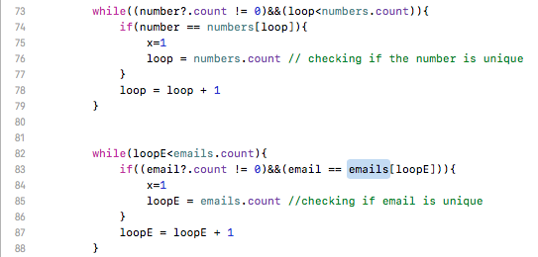

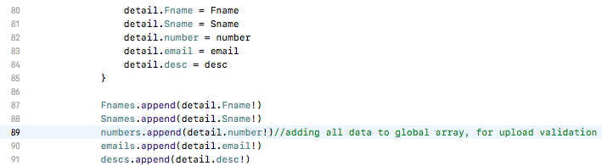To fix this I thought that I would be able to add all the data that is on the database, and be able to store it in the global arrays that I had previously made for making the validation. Therefore, none of the validation code has to be changed and all I need to do is append to the arrays within my HomeModel.

**Test 2 – Video 7 (test 6b only)**

|  |  |  |  |  |
| --- | --- | --- | --- | --- |
| **Test No.** | **Description** | **Test Data** | **Expected Result** | **Actual Result** |
| 6a | Input Valid Set of Data | -Valid | Data Is Uploaded | Data is uploaded |
| 6b | Input repeated data | -Invalid | Data isn’t uploaded | Data isn’t uploaded |

Note data doesn’t appear within Partners section due to time taken for the data to be downloaded to my app. Therefore, the validation of unique data does not fully work in very short time periods. As well as this, I haven’t implemented the validation of only one input per person, for the ease of texting. This piece of validation will be implemented next stage.

**Stage 7 - Deleting Details**

**Test 1 – Video 8**

|  |  |  |  |  |
| --- | --- | --- | --- | --- |
| **Test No.** | **Description** | **Test Data** | **Expected Result** | **Actual Result** |
| 7a | Trying to input two sets of different data | ‘N’, ‘123’,  ‘J’, ‘456’  -Invalid | Rejection of second piece of data. | Rejection of second piece of data. |
| 7b | Deleting data | -Valid | Data deleted. | Data deleted. |
| 7c | Re-inputting data after deletion | ‘N’, ‘123’,  -Valid | Data is inputted. | Data is inputted. |

Here I added a small amount of validation and saved data on my device. First, I made it so once my input has passed the validation it is uploaded to the database, and then saved locally along with a variable ‘hasInputted’ set as “1”. This variable is then added within my validation making sure it is not equal to one, meaning that the user hasn’t currently got data inputted within the database.

Then in the Partners file I made a function for the ‘Deleting Details’ button. Here I just made the variable ‘hasInputted’ equal to “0” as the current user no longer has data inputted. Also, I created a php file with the SQL to delete the details of the data which has been stored locally. I don’t change any of the stored details as it will just be overwritten when the user wishes to re-enter their details, after deletion.

**User Feedback**

One piece of user feedback, even though it wasn’t about this stage, was about the layout of the TextView (description). They mentioned how that it did not if in within the rest of the layout due to the square corners, whilst all other inputs had rounded edges. Therefore, I added two simple lines to curve the edges off making the layout much more appealing.

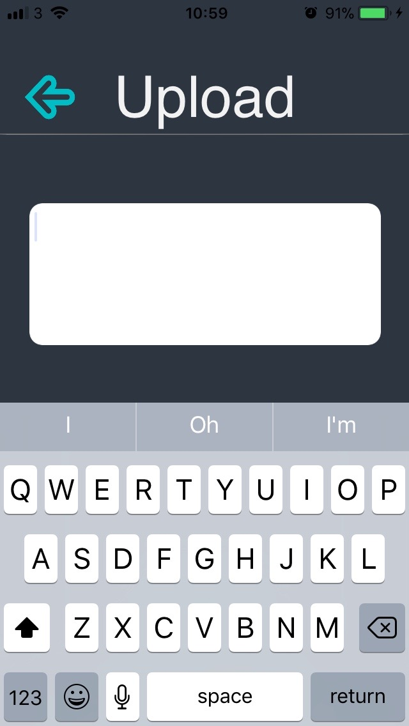

**Video 9**

Also, another user said that a pop up should occur once the ‘Delete Details’ was selected, to prevent an accidental touch.

**Late Code**

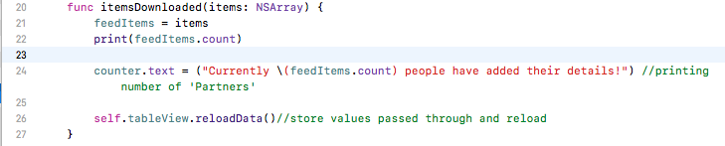Afterwards I added the counter for the number of people who have added data within the database. All that needed to be added was a TextView, then created an outlet to Partners file. Then added the following code:

I added it within the itemsDownloaded function as it refreshes and therefore the counter will be as up to date as possible.

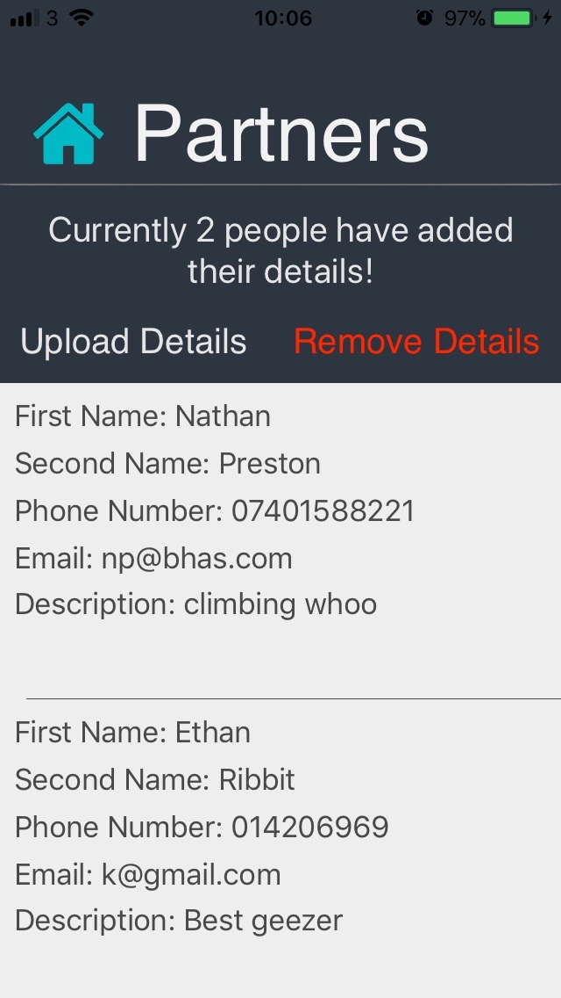

**Stage 8 – Uploading Routes**

I began this stage by creating a new database and table, like within stage 5.

Afterwards I created two new files for the two screens which would be viewed when accessing indoor and outdoor routes.

Then once all of it was setup I repeated the code from stage 5, however named the two new files ‘RoutesModel’ and ‘RoutesHomeModel’. Even though this section had the same functions the section5/6 the code needed to be repeated as there were new variables that were in use.

Once this was added I followed the way I had implemented this within a table in Stage 5/6.

**Test 1**

|  |  |  |  |  |
| --- | --- | --- | --- | --- |
| **Test No.** | **Description** | **Test Data** | **Expected Result** | **Actual Result** |
| 8a | Add data into database without picture | - ‘6c’, ‘Boulder Brighton’, ‘Big heel hook’  -‘6a’, ‘Boulder Brighton’, ‘Cave’  -‘6a’, ‘White Spider’, Fun…’  -Valid | All data inputted without error | Crash  -FAIL |
| 8b | Data outputted correctly | - ‘6c’, ‘Boulder Brighton’, ‘Big heel hook’  -‘6a’, ‘Boulder Brighton’, ‘Cave’  -‘6a’, ‘White Spider’, Fun…’  -Valid | All data outputted without error | Crash  -FAIL |

**Error 1**

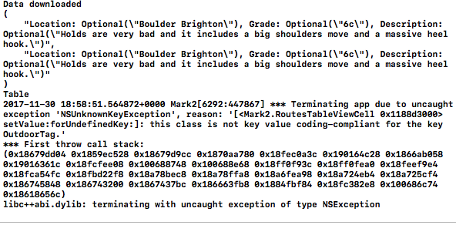This error was due to my table from my UI having incorrect connections to its Data Source and Delegate. This was as when I was making my UI, to save time, I copied and pasted the table from the Partners section. Thinking it would only copy and paste its UI, I used it and received a NSException.

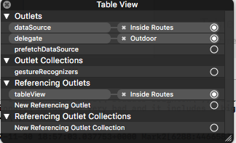These are normally due to bad connections, or invalid outlets. In this case it was because when I pasted the table from the Partners section it still had its delegate and data source connected to the Partner view controller, so when I made the delegate to the Indoor Routes view controller it crashed. This was swiftly fixed, as I made a new table then reset everything up.

**Test 2**

|  |  |  |  |  |
| --- | --- | --- | --- | --- |
| **Test No.** | **Description** | **Test Data** | **Expected Result** | **Actual Result** |
| 8a | Add data into database without picture | - ‘6c’, ‘Boulder Brighton’, ‘Big heel hook’  -‘6a’, ‘Boulder Brighton’, ‘Cave’  -‘6a’, ‘White Spider’, Fun…’  -Valid | All data inputted without error | All data inputted without error. |
| 8b | Data outputted correctly | - ‘6c’, ‘Boulder Brighton’, ‘Big heel hook’  -‘6a’, ‘Boulder Brighton’, ‘Cave’  -‘6a’, ‘White Spider’, Fun…’  -Valid | All data outputted without error | Data piece two was outputted twice, and there was 3 empty rows in all climbing centres. |

**Error 2**

In test two there were to major errors, the first was about the number of rows. In each climbing centre three empty cells were outputted. This was because when defining the number of rows per table I just set it to the total number of rows within my database, which is the number of pieces of data.

Stage%208/itemCountError.png

To fix this I made a loop going through all the locations within my database, then I created a variable which stored the location that the user pressed on. Then if the value of the variable was equal to a location within the database a new row would be added.

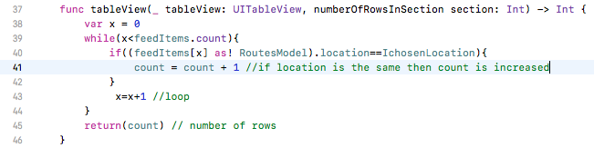

This fixed the number of rows issue, however there was still an issue with that the first piece of data for Boulder Brighton wasn’t being outputted

**Error 3**

When I ran my code within Test 2 I found that within the Boulder Brighton routes my second piece of data was being outputted twice, whilst the first piece of data wasn’t being outputted at all. When inspecting my code, I found the reason for this was due to the first piece of data overwriting my first piece of data.

So with this code, every time the loop would output the first set of data and carry on for it to be overwritten.

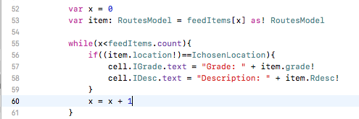

To fix this, I needed to create a loop that would break once the data has been inputted whilst remembering where it was in the loop for the next row of data, if there is one. Yet, this variable that needed to remember where the loop was would need to be reset once all the rows had been filled. I achieved this in my final code.

**Test 3**

|  |  |  |  |  |
| --- | --- | --- | --- | --- |
| **Test No.** | **Description** | **Test Data** | **Expected Result** | **Actual Result** |
| 8a | Add data into database without picture | - ‘6c’, ‘Boulder Brighton’, ‘Big heel hook’  -‘6a’, ‘Boulder Brighton’, ‘Cave’  -‘6a’, ‘White Spider’, Fun…’  -Valid | All data inputted without error | All data inputted without error. |
| 8b | Data outputted correctly | - ‘6c’, ‘Boulder Brighton’, ‘Big heel hook’  -‘6a’, ‘Boulder Brighton’, ‘Cave’  -‘6a’, ‘White Spider’, Fun…’  -Valid | All data outputted without error | All data outputted without error |

**Test 4**

|  |  |  |  |  |
| --- | --- | --- | --- | --- |
| 8c | Input through app without picture, see if it is outputted | - ‘6c’, ‘Almscliff’, ‘super high’  -Valid | Data is inputted without error | Data is inputted without error |
| 8d | Data outputted correctly | - ‘6c’, ‘Almscliff’, ‘super high’ | All data outputted without error | All is outputted except from the Location. |

**Error 4**

This error was due to the Picker View within swift. The way the location is selected is by the current location which is being view is stored into a variable, then inputted into the database. However, if the picker view is not touched Almscliff is supposedly chosen, however as it is not moved nothing is chosen. Therefore, I created a simple if statement to make the variable set to Almscliff if it was previously empty.

**Test 5**

|  |  |  |  |  |
| --- | --- | --- | --- | --- |
| 8c | Input through app without picture, see if it is outputted | - ‘6c’, ‘Almscliff’, ‘super high’  -Valid | Data is inputted without error | Data is inputted without error |
| 8d | Data outputted correctly | - ‘6c’, ‘Almscliff’, ‘super high’ | All data outputted without error | All data outputted without error |

To be do the next parts of this stage, I needed to find a way to store photos. There are various ways to do this. My first idea was to use my database that I used with my database where all the other details of the routes are stored.

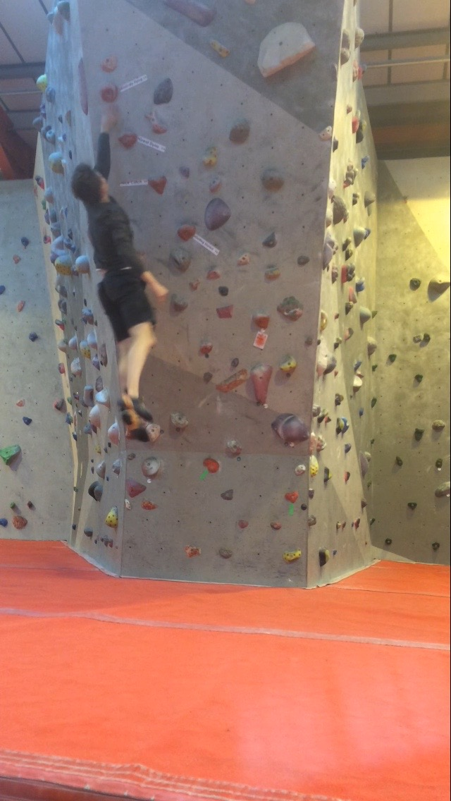To do this the image would have to be converted to a Long Blob. Once chosen the input to the database was very simple, it was identical to all other details input. As my photo I used:

Within my app I made the output construct the same as I had before Therefore, the photo would need to be extracted via a PHP file, just as the rest of my data had been. While researching how to output my data as an image, I found out that it wasn’t as simple as all the other data. The way I needed to input the photo to XCode was to have the image displayed upon a URL, by its self, and then XCode would be able to input the photo.

**Test 6**

|  |  |  |  |  |
| --- | --- | --- | --- | --- |
| 8e | Add data into database with picture | -‘6a’, ‘Boulder Brighton’, ‘big dino’, image  -Valid | All data inputted without error | All data inputted without error |
| 8d | Data outputted correctly | -‘6a’, ‘Boulder Brighton’, ‘big dino’, image | All data outputted without error | All data outputted without error |

**Error 5**

The one photo had been outputted correctly, however once another photo was added to the database it meant that none of it would work. As XCode will only input the photo if it was by its self within the webpage, and my php file would output all photos on one webpage. Thus causing the output to no longer be reliable.

The next way to store the image was to store it within the files of the server, such as where the php files are stored. This is perfect for the photos as each one can be given a unique name, and accessing them will be as simple as: MyDomain/File/NameOfPhoto.

**Test 7**

|  |  |  |  |  |
| --- | --- | --- | --- | --- |
| 8e | Add data into database with picture | -‘6a’, ‘Boulder Brighton’, ‘big dino’, image  -Valid | All data inputted without error | All data inputted without error |
| 8d | Data outputted correctly | -‘6a’, ‘Boulder Brighton’, ‘big dino’, image | All data outputted without error | All data outputted without error |